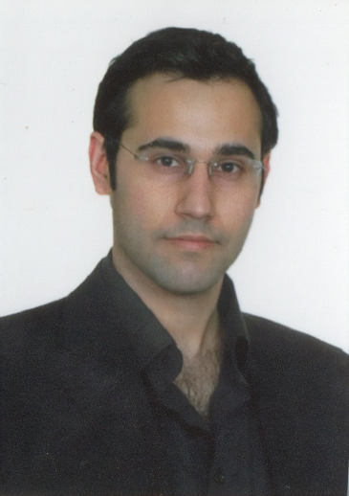

Abstract

Characterized by time-varying arrivals, multi-stage service, and multi-class patient population, emergency rooms (ERs) are complex healthcare delivery systems, where optimizing the staffing levels of physicians is a challenge. In this work, we studied a physician staffing and associated routing problem for physicians and proposed a new staffing rule to meet tail probability of delay (TPoD) type service targets (e.g., serve Level 2 patients in 15 minutes and meet this goal at least 95% of the time).

Capturing the time-varying patient flow in the ER with a multi-class multi-stage queuing network, we developed a new staffing algorithm to transform the expected workload on ER physicians into staffing decisions. We analytically showed the asymptotic effectiveness of our staffing rule on stabilizing TPoD for efficiency-driven M/M/s queues, and numerically demonstrated its robustness and optimality in various time-varying ER settings via realistic and data-driven simulation experiments. We further showed that as the service complexity of an ER increases, hybrid routing rules, using pre-determined (static) priorities and (dynamic) current system state jointly, become necessary to meet TPoD targets.

Çağlar Çağlayan is an assistant professor in the Department of Industrial Engineering at Clemson University. His research interests include mathematical modeling and computational optimization of dynamic processes under uncertainty and data- and decision-centric healthcare analytics. He particularly focuses on health service operations and disease management problems and utilizes a broad range of analytical methods to gain insights from data and improve medical decision-making under uncertainty.

About the Speaker

Physical Staffing in Emergency Rooms (ERs): Opening the Black Box of ER Care via a Multi-class Multi-Stage Network

Dr. Caglar Caglayan

Assistant Professor

Department of Industrial and Systems Engineering

Clemson University

Operations Research Seminar

Martin Hall

M-103

Wednesday, January 22

11:15 am – 12:15 pm